**Introduction**

The topic of this project is to create a chatbot to shop for essentials during pandemic using Watson assistant. I have created a chatbot using Watson assistant service in IBM cloud and have integrated it using Node-red. All the intents, enteties and dialogs were create using Watson assistant. Finally to create the UI of the bot I used Node-red, although I have encountered some problems while integrating the UI but it was done at last.

**Node-RED**

To create the UI for the chatbot I have used the script provided by the Web chat Integration in the Watson assistant service. I used the script in the Node-red to integrate my chatbot's UI to a webpage.

The node flow which I have used is given below:

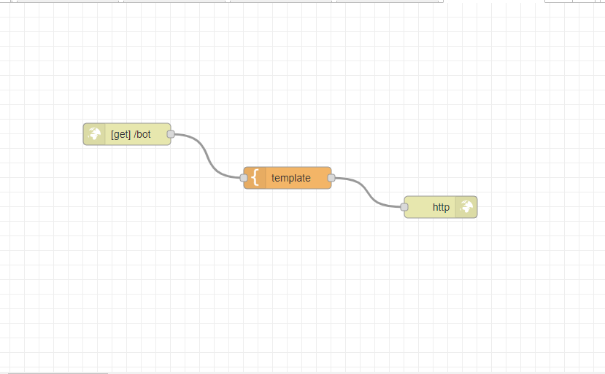

User Interface:

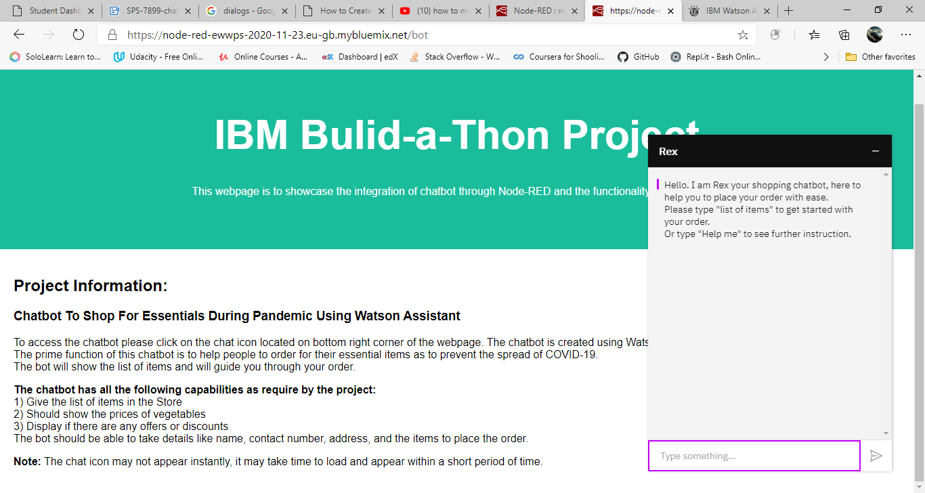

**Problems**

Problem faced by me were that the following node flows were not able to provide the desired output from the chatbot due to insufficient knowledge:

Node flow:

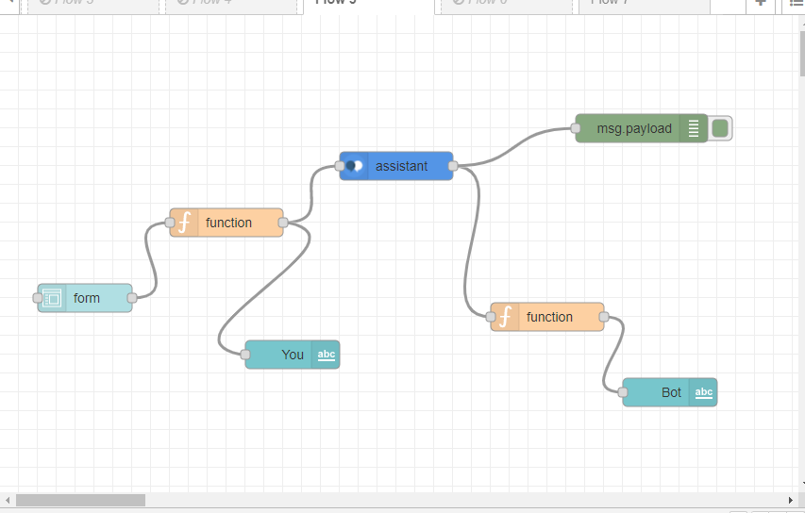

User Interface:

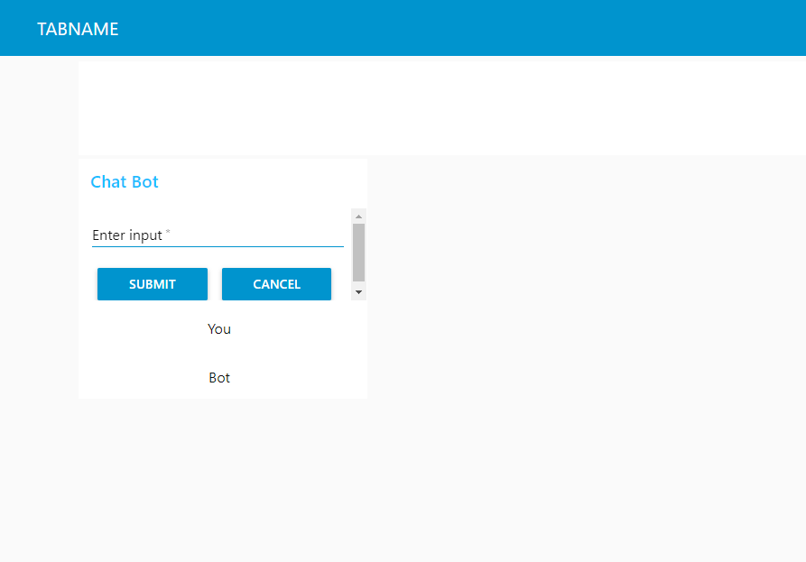

Node flow:

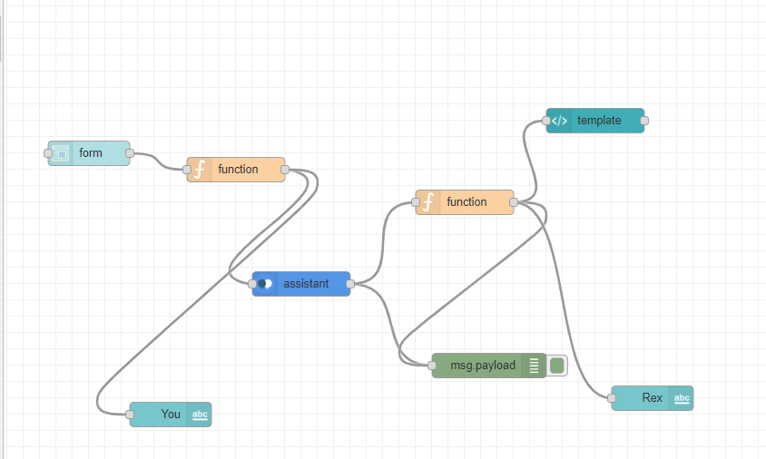

User Interface:

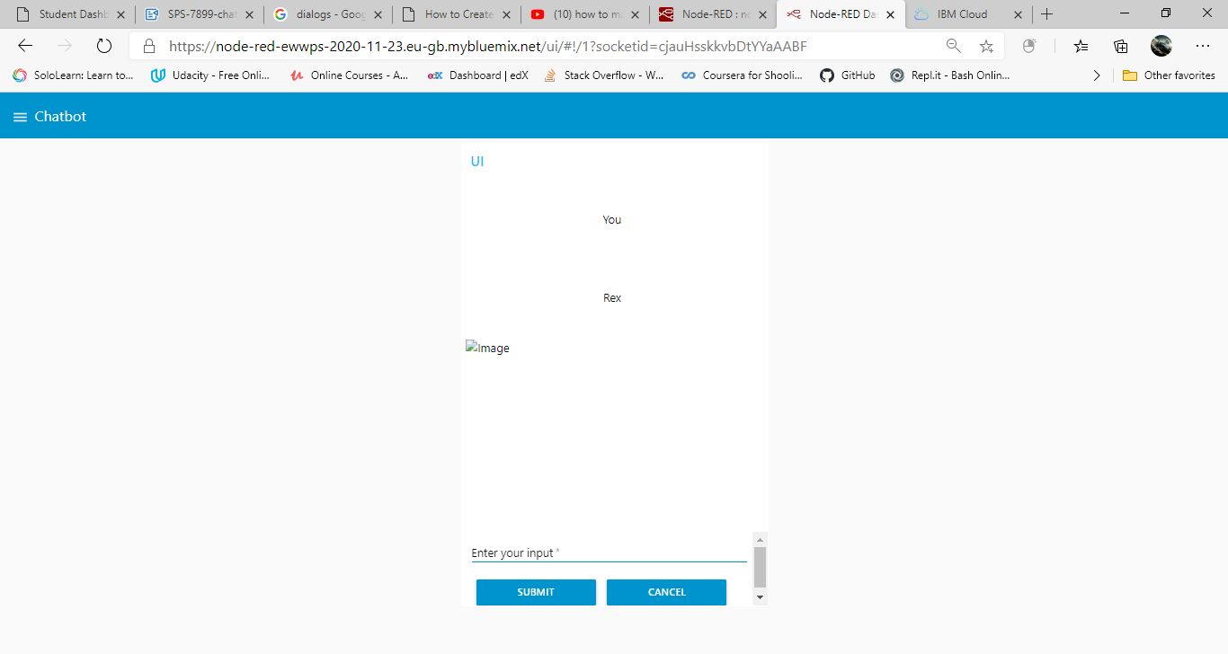

**Result**

The chatbot was successfully made and integrated. The chatbot can perform all the function require by the project.

**Advantages**

1) This type of chatbot can be used in times like now (Pandemic) where social distancing is necessary.

2) Ease for ordering essentials.

3) More convinent for people with busy shedules.

4) No crowds and sales pressure.

5) Always avaiable and accessible

**Disadvantages**

1) Bot maybe unable to respond for some queries.

2) Less control over shipping.

3) May encounter techical problems.

**Conclusion**

I would conclued this project by saying that chatbot service is a great accessibility as it is available all time. I had a great experience while working in this project. In my opnion chatbots can through a huge audience and can be effective compare to humans for certain aspects.

**Future Scope**

This chatbot service has more potential. In future it can be able to hold hold a human level conversation. With integration of chatbot with NLP, NLU and NLG this might be possible. Although more work will be required but its UI can be simplified further and can be more user friendly.